

Offshore Renewable Energy Declaration

Gippsland, Victoria—Public Consultation Summary Report

# Contents

Contents 2

1. Introduction 3

2. Development of the Notice of Proposal 3

3. Consultation process 3

3.1 Public consultation 3

3.2 Traditional Owners 4

3.3 Community open house sessions 4

3.4 Online local industry sessions 4

4. Analysis of submissions 4

5. Overview of submissions 5

5.1 Types of respondents 5

5.2 Location of respondents 5

6. Feedback within submissions 6

6.1 General sentiment 6

6.2 Support for offshore renewables and opportunities for the region 6

6.2.1 Addressing climate change, emissions reductions and clean, renewable energy 6

6.2.2 Community and local economy 7

6.2.3 Environment 7

6.2.4 Other opportunities and benefits 7

6.3 Existing marine users and local concerns 7

6.3.1 Environmental values 7

6.3.2 Visual amenity 8

6.3.3 Area boundary selection and general location 9

6.3.4 Access to the area 10

6.3.5 Commercial fishing 10

6.3.6 Recreational fishing 11

6.3.7 Tourism 12

6.3.8 Onshore impacts and transmission 12

6.3.9 Health impacts 12

6.3.10 Decommissioning 12

6.3.11 Cost 13

6.3.12 Other concerns or issues 13

# Introduction

On 5 August 2022, the Minister for Climate Change and Energy (the Minister) announced an area offshore of Gippsland, Victoria, that they proposed to consider for a potential declaration under the *Offshore Electricity Infrastructure Act 2021*. This was the first such proposal under the new legislative framework and was a landmark step in enabling the development of offshore renewable energy in Australia.

The purpose of this report is to provide an overview of consultation on the Notice of Proposal, including a summary of the responses received during targeted and public consultation, and the Australian Government’s response to feedback. The responses received as part of the public consultation process reflect considerable time and effort on the part of the responders. The submissions provided valuable information for the Minister when deciding to declare the area off Gippsland, Victoria as suitable for offshore renewable energy infrastructure.

The opinions expressed in this report were presented by stakeholders during the public consultation period and do not necessarily reflect the views of the Australian or Victorian governments.

# Development of the Notice of Proposal

The Notice of Proposal to declare an area off Gippsland, Victoria as suitable for offshore renewable energy infrastructure was developed through consultation with Commonwealth and Victorian Government agencies.

# Consultation process

## Public consultation

The Minister published the Notice of Proposal for the area off Gippsland on 5 August 2022. This commenced the statutory public consultation period as required under the *Offshore Electricity Infrastructure Act 2021*. The public were able to make submissions via the Department of Industry, Science and Resources Consultation Hub web platform. On 7 October 2022, the public consultation period closed.

The Notice of Proposal was accompanied by a dataset titled ‘*Offshore Electricity Infrastructure Act 2021* – *Proposed Area – Gippsland, Victoria*’ that identified the proposed area to be declared. An indicative map of the proposed area was also included in the notice. The Consultation Hub page included a number of resources to provide submitters with additional information in relation to the proposal. This included:

* A document providing an overview of the proposed area titled ‘Overview of the Proposed Area – Gippsland, Victoria’
* A document containing supporting information on the proposal in a FAQ format. This document was titled ‘Supporting Information for the Region – Gippsland, Victoria’
* A document providing an overview of some of the existing marine users and interests in the vicinity of the proposed area titled ‘Marine Users and Interests – Gippsland, Victoria’
* A shapefile of the proposed area for download
* A link to an interactive map of the proposed area hosted by Geoscience Australia.

Information on the consultation was shared across a number of platforms, including [on](https://www.dcceew.gov.au/) the Department of Climate Change, Energy, the Environment and Water’s (the department) [website](https://www.dcceew.gov.au/energy/renewable/establishing-offshore-infrastructure) and on departmental social media channels, Twitter, Facebook, Instagram and LinkedIn.

The aim of the consultation was to capture views on the proposal to declare the area, to inform the Minister’s decision on whether the proposed area is suitable for offshore renewable energy.

## Traditional Owners

The department worked closely with the Victorian Department of Environment, Lands, Water and Planning (DELWP) to conduct respectful, appropriate and two-way engagement with First Nations groups prior to and during the Gippsland Public Consultation utilising DELWP’s *Key Relationship Holders* approach. Under this approach, departmental staff were closely guided by the DELWP Gippsland Program Manager for Community Partnerships in Renewable Energy, who facilitated information sharing and engagement with traditional owners of the land adjacent to the Gippsland proposed area, the Gunaikurnai, Bunurong and Boon Wurrung peoples, on behalf of the department.

This approach resulted in:

* Clear, appropriate and respectful information sharing
* Culturally appropriate language in written communications published on the DCCEEW website and as part of the public consultation
* In person meeting on country with the Gunaikurnai Land and Water Aboriginal Corporation (GLAWAC).

DELWP worked with the GLAWAC and Bunurong Land Council Aboriginal Corporation (BLCAC), the two regionally recognised organisations for Traditional Owners in land and waters adjacent to the Gippsland Proposed area, to support them throughout the submission process.

## Community open house sessions

The Gippsland community was invited to participate in a number of open house sessions held during the consultation period. In total, six open house sessions were held across the Gippsland region (Morwell, Lakes Entrance, Sale, Yarram, Wonthaggi and Leongatha) from 29 August to 1 September 2022, attracting more than 500 attendants.

For each open house, departmental staff were available to talk to the community, together with representatives from the Victorian Government Department of Environment, Land, Water and Planning, VicGrid, and the Latrobe Valley Authority.

At the sessions, attendees were briefed by government representatives on elements of the proposal, provided the opportunity for the local community to ask questions, discuss key issues and understand the importance of providing feedback via a submission.

## Online local industry sessions

Relevant local industry stakeholders were invited to participate in a number of online, industry specific sessions held during the consultation period. Five sessions were held between 17 August and 25 August. These sessions were targeted to the following industry groups: Aviation and Emergency Services, Commercial Fishing, Tourism, Community Groups and Recreational Fishing.

A total of 79 individuals attended these online sessions. These sessions allowed targeted discussions on the interaction of offshore renewable energy projects with specific local industries, and gave an opportunity to answer any questions local industry representatives might have, in order to better equip themselves to provide informed feedback to the consultation process.

# Analysis of submissions

The department undertook an analysis of the submissions received. The analysis was to understand overall public sentiment of the proposal represented in the submissions, and to identify the range of views to assist the Minister’s decision whether to declare the area as suitable for offshore renewable energy.

# Overview of submissions

## Types of respondents

Respondents were able to respond as an individual or on behalf of an organisation. Only 91 submissions (~12%) were made on behalf of an organisation, and the remaining 674 submissions (~88%) were made by an individual or individuals. Respondents were also asked to categorise the sector that best describes themselves or their organisation. Figure 1 shows the breakdown of sectors for all responses. Overall, the largest portion of responses came from members of the public (~83%). The next two sectors represented were non-government/community organisations (3.6%) and those in the fishing and port sector (2.3%).

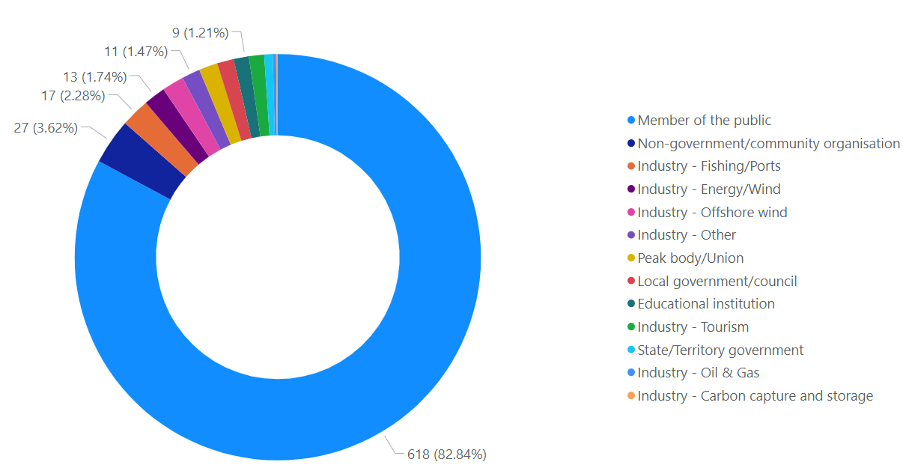

Figure 1 – Responses by sector

## Location of respondents

Respondents were asked to identify their postcode. Over 96% of submissions were from Victorian residents. Two thirds of the submissions were received from residents in the five Gippsland local council areas. Of the submissions from residents of the Gippsland local council areas, over half were from residents in South Gippsland, and a quarter were from Bass Coast (Figure 2).

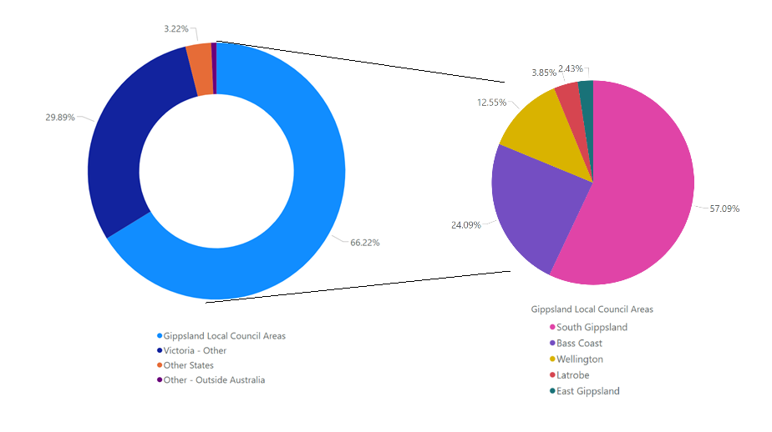

Figure 2 – Location of respondents, overall and within Gippsland Local Council Areas

# Feedback within submissions

## General sentiment

Submissions were not required to specifically identify their support or opposition for the proposal. However, the department analysed the responses and categorised the general sentiment of each submission.

Overall, there was mixed sentiment on the proposal (**Error! Reference source not found.**). Over 40% of submissions were supportive, or conditionally supportive, of the proposed area. Approximately 20% of submissions were opposed to a specific part of the proposed area, and one third of submissions were opposed to the proposal.

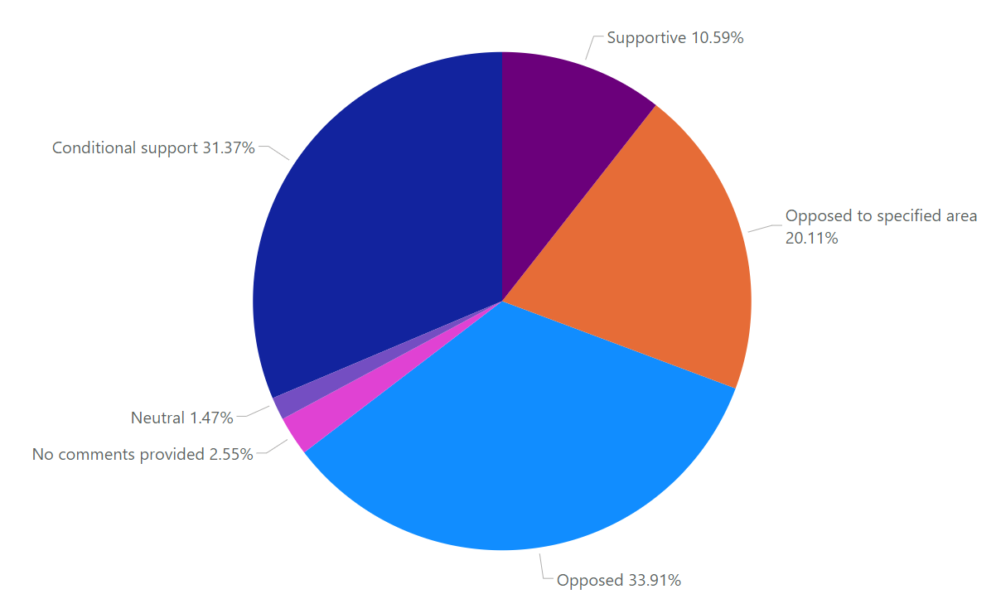

Figure 3 – Sentiment of the proposal within the submissions

## Support for offshore renewables and opportunities for the region

A large number of submissions (313) stated they were supportive of the proposal. Three quarters of these supportive submissions wanted particular concerns addressed.

Those supportive of offshore renewables in the region noted a number of benefits and opportunities for the region. These are expanded on below.

### Addressing climate change, emissions reductions and clean, renewable energy

There were 86 submissions received which noted the benefits of offshore renewable energy contributing to addressing climate change. This included the reduction of greenhouse gas emissions and contributing to Australia’s emissions reduction targets. A number of submissions raised that this will provide clean, renewable and cheaper electricity to the region and into the grid.

The region is known for its brown coal power stations. A number of submissions noted that offshore wind is vital to help the region transition away from brown coal, and provide cleaner and cheaper electricity to the region.

More broadly, submissions referenced a number of general benefits associated with offshore renewable energy generation. These included increasing the diversification of Australia’s electricity generation and contributing to decarbonising the economy.

Submissions also noted that by declaring an area suitable for offshore renewable energy infrastructure, this will help facilitate the construction and operation of renewable energy infrastructure, including potential offshore wind farms. Submissions stated that the operation of offshore wind turbines will generate renewable energy and reduce reliance on fossil fuels, thereby contributing to Australia’s emission reduction targets.

### Community and local economy

There were 37 submissions received that noted the benefits of offshore renewable energy projects to the community and local economy. These included broad sentiments focused on economic benefits such as an increase in job opportunities and investment in the region. Other submissions raised the possibility that a new offshore renewable energy industry may assist in transitioning coal workers into new employment.

Submissions also highlighted a number of potential community benefits, such as the opportunity for a new offshore renewable energy industry to work closely with local and Traditional Owner communities to produce broader shared benefits, as well as a potential increase in local tourism and other investment opportunities.

Submissions also highlighted future benefits for the community, with improved infrastructure, and access to more technology and engineering jobs.

### Environment

A small number of submissions noted the potential environmental benefits of offshore renewables, separate to the broader climate benefits associated with renewable energy. These submissions identified the potential for offshore renewables to create new habitats for marine life in the offshore area by functioning as artificial reefs.

### Other opportunities and benefits

A number of submissions noted that the location of this area is ideal for wind farms as they are close to demand and onshore connections points. Other submissions noted that by placing renewable energy projects offshore they are not taking up space on land or affecting landowners and others within the area.

A number of potential offshore wind farm developers provided submissions, noting the significant opportunities the declaration of this area opens up for this industry and the region more broadly.

## Existing marine users and local concerns

### Environmental values

Environmental concerns were raised in 369 submissions. Throughout these submissions, a number of common concerns were expressed (see Figure 4), with general environmental concerns, and impacts on birds and whales (including dolphins) being the most prominent. Other concerns included impacts on penguins, seals, and on reef and seabed habitats, particularly around Wilsons Promontory.

Concerns for birdlife were generally focused on migratory bird species, and the interference of wind turbines on migration routes and offshore feeding grounds. The Orange Bellied Parrot’s migration between Tasmania and the Australian mainland was also specifically identified by a number of submissions. Migratory bird concerns were particularly prevalent to the west of Wilsons Promontory and in the Waratah Bay region, reflecting the presence of Ramsar listed wetlands in the region, which seasonally host migratory species.

Waratah Bay, and the Bass Coast more broadly, were highlighted due to whale migrations close to the coast, with regular sightings of whales within Waratah Bay. Concerns highlighted multiple potential issues for whales, including turbines forming a physical barrier, vibrations during operation interfering with whale sonar, and similar concerns for the louder, more intense noise during construction. Similar concerns were identified for resident dolphin populations.

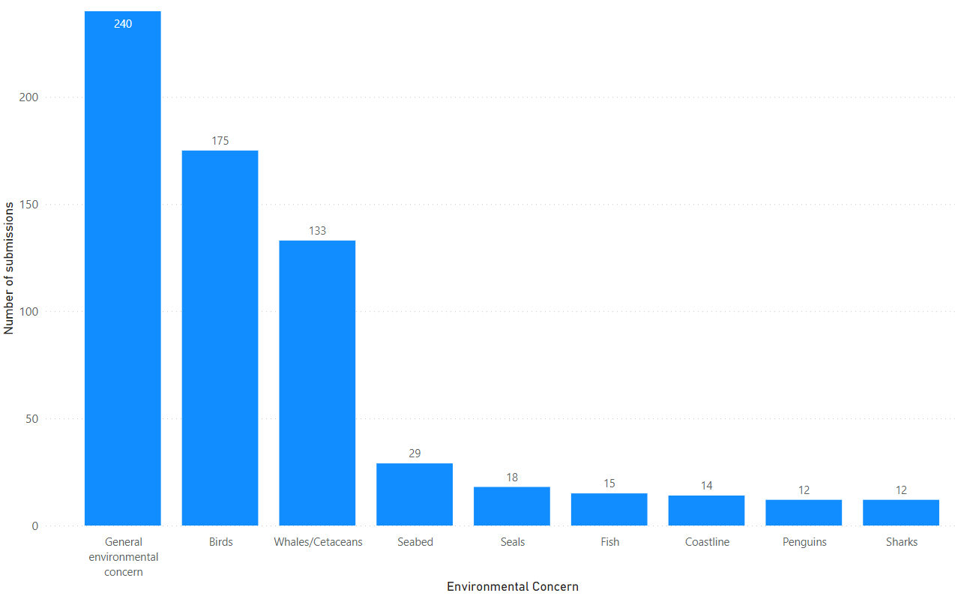

Figure 4 – Number of submissions with different environmental concerns raised

A number of submissions were concerned about impacts on the seabed, including on reef structures. Concerns were raised that the construction of wind turbines would damage the seafloor, in particular the areas off Wilsons Promontory that host significant marine communities. These submissions also made reference to the Marine Parks within Victorian waters – Wilsons Promontory Marine National Park and Bunurong Marine National Park – when identifying the sensitivity of the marine environment.

Concerns were also raised about impacts on the coastline. These submissions identified existing issues with erosion along the Bass Coast to the west of Wilsons Promontory, and claimed that the construction of offshore renewable energy infrastructure may alter coastal processes in a manner that would exacerbate existing issues.

The area around Wilsons Promontory was also identified as a concern for seals and sharks. Wilsons Promontory was identified as a nursery area for White Sharks, with the risk of interference to this area from the development of offshore renewable energy infrastructure raised as a concern. Impacts on seal colonies present on several islands offshore of Wilsons Promontory also raised concerns.

Concerns relating to penguins were concentrated in comments related to the west of Wilsons Promontory and around Phillip Island, with particular focus on the Little Penguin population on Phillip Island.

A large proportion of submissions raised general concerns for environmental matters, such as marine life as a whole, onshore environmental impacts associated with transmission infrastructure, and concerns with potential marine pollution associated with infrastructure construction and operation. Submissions also identified concerns with the adequacy of the *Environmental Protection and Biodiversity Conservation Act 1999* (EPBC Act) processes to identify and manage environmental risks, and concerns with the cumulative environmental impact of multiple projects.

### Visual amenity

The impact of offshore wind projects on the visual amenity of the Gippsland region was a prominent concern raised throughout the consultation. Of the 765 submissions received, 401 submissions mentioned the impact on visual amenity as an issue. There were two main categories of concern about the potential for offshore wind turbines being visible from the coastline:

1. Reducing the visual beauty of places of natural significance.
2. Diminishing the visual outlook from places of natural significance, townships and along coastlines generally.

It is important to note that concerns were raised on the visual impact of offshore infrastructure during daylight hours, as well as light pollution caused by hazard and navigational warning lights, required on offshore infrastructure for safety reasons, during the night. Submissions raising light pollution at night discussed stargazing and hunting for the Aurora Australis as activities significant to Gippsland’s national natural importance.

Opposition to visual impacts was demonstrated to varying degrees across submissions, both in the tolerance of the size of turbines and their distance from shore, as well as potential project site locations along the coastline.

Submissions raising visual amenity concerns were spatially categorised[1] by region (Figure 5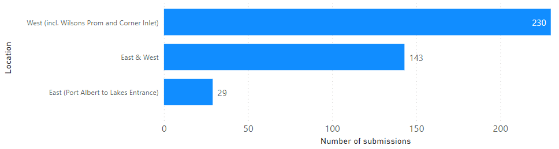

). Over 370 submissions had visual amenity concerns in relation to the region to the west of Wilsons Promontory. This was more than double the number of submissions with visual amenity concerns in relation to the region to the east.



Figure 5 - Visual amenity concerns by region

The majority of submissions raising visual amenity concerns were from residents in the Gippsland Council regions, with almost half of submissions with visual amenity concerns coming from the South Gippsland region. Almost a third of submissions opposing the visual impact of offshore turbines came from other parts of Victoria outside of the Gippsland region, with many of these describing themselves as long-term visitors to the region or owners of holiday homes.

In addition to submissions from the general public, a number of regionally significant organisations raised concerns on the visual impact of offshore wind projects. Bass Coast, South Gippsland, and East Gippsland Shire Councils all acknowledged that projects in the proposed areas would transform the seascape and have significant impact on the region’s iconic natural attractions. Both the Bass Coast Shire Council and the South Gippsland Shire Council raised that the area to the west of Wilsons Promontory is too close to shore given the size of current and future turbines. Regional tourism bodies also raised concerns on the proximity of proposed areas and the potential impact on views, and that despite supporting renewable energy, could not support it “at the cost of coastal amenity that could detract from the visitor appeal and experience”. Other important regional organisations raised similar concerns, but indicated a preference for their submissions to remain private and confidential.

### Area boundary selection and general location

Thirty-nine submissions raised concerns with the boundaries of the proposed area or particular locations. The majority of these submissions were in opposition to the proposed sections being as close to shore as they were, especially in proximity to Wilsons Promontory and Waratah Bay. These submissions did not provide specific justification as to why the proposed areas were too close to shore, and therefore could not be categorised alongside prominent themes such as visual amenity or environmental concerns. Some submissions raised community opposition as the primary reason to increase the distance from shore, or restrict development to the eastern side of Wilsons Promontory.

In some instances, submissions had concerns with area boundary selection due to a misunderstanding of the meaning behind the “area to be avoided” (ATBA; under Schedule 2 of the *Offshore Petroleum and Greenhouse Gas Storage Act 2006*) which was included in the Gippsland proposed area maps. These submissions were supportive of the ATBA being available to offshore renewable energy projects so that existing infrastructure could be reused. One submission raised a concern that shifting the whole area further out would delay the development of fixed foundation projects, due to the need to reassess and re-site infrastructure.

### Access to the area

Thirty-three submissions, predominantly from the recreational and commercial fishing sectors, expressed concern that the introduction of offshore renewable energy would restrict access to other users of the marine space.

The main concern in these submissions was the potential for existing users to be restricted or excluded from areas proposed for offshore renewable energy. This included areas within the vicinity of offshore wind farms and subsea transmission cables. The lack of access would have potential safety, social and economic impacts on existing users.

Some submissions suggested learning from international best practice and lessons in other countries for how offshore renewable energy could share or coexist with the marine space and other users. Other submissions put forward options that may be explored to manage access. For example, access could be restricted during the construction and maintenance phases for offshore renewable energy, but opened up during the operation phase.

Other submissions with concerns related to access raised issues regarding commercial and recreational flights, transport of personnel to oil and gas platforms, and subsea communication cables.

### Commercial fishing

Thirty-three submissions raised the importance of the existing commercial fishing industry in Gippsland and the potential impacts on this industry from the establishment of an offshore renewable energy industry.

Many concerns were related to offshore renewable energy restricting access to commercial fishing areas. Some of these submissions noted that the marine space cannot be effectively shared between offshore renewable energy and commercial fishing due to the large areas needed for both industries. These submissions recognised that the various types of commercial fisheries in the Gippsland region (e.g. trawling, Danish seine, gillnet, longline) would be impacted differently with the introduction of offshore renewable energy.

Challenges identified in these submissions included:

* Impacts on enduring legal fishing rights granted by Commonwealth and State governments
* Increased competition for reduced marine space
* Reduced navigational and human safety
* Short-term, long-term and cumulative economic and social impacts
* Impacts on fish species and the environment in the marine area.

Offshore renewable energy projects could impact the economic viability of commercial fisheries and people’s livelihoods due to reduced profits, decreased value of fishing rights, and reduction of potential for future discoveries of fishing grounds.

Questions were raised about how compensation for potential economic impacts and reduction in fishing rights and revenue would be arranged. Some stakeholders also saw this as an opportunity to better understand the impacts, improve marine planning and identify how the industries can coexist.

Commercial fishing industry groups raised concerns that development of offshore renewable energy is occurring ahead of a clear policy to manage issues such as consultation, access, conflict mitigation, displacement and compensation. There was a lack of understanding of the process for an area declaration being the first of a number of steps for consultation under the new *Offshore Electricity Infrastructure Act 2021*. Clear policy is seen as essential to successfully integrate new industries, recognise all users of the marine space and balance competing interests. Submissions noted a need for greater understanding and called for more information on the impacts of offshore renewable energy on commercial fishing, and how these competing interests can be balanced.

Recommendations put forward by industry groups included:

* Conditions placed on offshore renewable energy proponents to minimise impacts on fishing
* Fair compensation paid to commercial fishing for impacts from offshore renewable energy
* Conditions placed on proponents to pay into a fund for decommissioning of infrastructure
* Commercial fishing industry to be consulted throughout the process of the establishment of offshore renewable energy
* A framework for coexistence with key stakeholder groups be established and agreed.

Industry groups do not necessarily oppose shared marine spaces with offshore renewable energy, but rather seek to cooperate and reduce mutual risk and impact.

### Recreational fishing

Twenty-nine submissions raised concerns related to the recreational fishing sector in Gippsland. There were similar themes in these submissions to those made by the commercial fishing industry; however, there were also some significant differences.

Recreational fishing is a significant activity in the Gippsland region. One concern raised in these submissions was the potential restrictions to fishing areas that may be introduced due to offshore renewable energy. Stakeholders pointed to the need for consideration of how the area proposed can be shared with existing users. A number of submissions pointed to the greater possibility for recreational fishing to coexist with offshore renewable energy than for commercial fishing.

Submissions also raised concerns around boating safety during the construction and operation of wind farms. It was suggested that the risk of accidents and collisions would increase with offshore wind farms, particularly due to navigational and mechanical failures during severe weather conditions.

A number of these submissions recommended that offshore renewable energy be located a certain distance (ranging from 5-20km) from the coastline, to avoid risks for recreational fishing and other users. If offshore renewable energy was located close to the coast, this would force recreational fishing activities to venture further out with increased risk to safety.

The impacts to the marine environment and on fish habitats and stocks, were raised in a number of these submissions. The need for more research on both positive and negative impacts from offshore renewable energy was flagged. A small number of these submissions indicated the potential for positive impacts on fish stocks over time through the infrastructure acting as fish attracting devices (FADs). However, a greater number of submissions raised concerns about the potential negative impacts on reefs and other commonly used recreational fishing areas.

One submission recommended the need for a recreational fishing body to be set up to assist during the development of the offshore renewable energy industry.

### Tourism

Twenty-two submissions raised concerns regarding the impact of offshore renewables, particularly wind farms, on tourism, a significant industry in the Gippsland area.

A tourism industry group (Destination Gippsland) stated that the Gippsland region attracts over 7 million visitors per year, generates over $1.5 billion in visitor expenditure and supports over 11,000 tourism related jobs. The coastline west of Wilsons Promontory National Park stretching to Phillip Island (South Gippsland and Bass Coast) attracts 2.86 million visitors per year.

The majority of these submissions were concerned that the construction of offshore wind farms will affect the environment, coastal views and the unique natural beauty of the area. Many submissions stated that tourism in the area relied on the environment and coastal views, and that offshore wind farms may have a negative impact on tourism, including loss of income, closure of businesses and increased unemployment. The submission from Destination Gippsland supported renewable energy and the economic opportunity for Gippsland, but not at the cost of coastal amenity that could detract from visitor appeal and experience, or biodiversity and landscape values supporting tourism.

Submissions with tourism concerns sought further clarification and information regarding the scale of the proposed development area, proximity to the coastline, the design of individual projects, cumulative impacts and changes to visual amenity from prominent visitor destinations. It was requested that further investigation be undertaken into whether the local tourism sector will be adversely impacted by projects being located in the area, and the potential impact on the housing and rental accommodation, as a new energy workforce potentially increases demand.

### Onshore impacts and transmission

Onshore impacts of offshore renewable energy infrastructure development were identified as a concern in seventy-five submissions. The majority of these submissions related to concerns with the impacts of transmission lines across the Gippsland region, and the lack of information available regarding locations of transmission routes and associated onshore infrastructure. Submissions advocated for transmission lines to be located underground to reduce impacts on nearby communities and landholders.

In addition to concerns with transmission infrastructure, submissions also identified concerns for the capacity of existing infrastructure in the Gippsland region to cope with the development of an offshore renewable energy industry. In particular, submissions were concerned that existing road infrastructure would be unable to handle increased heavy vehicle traffic transporting offshore renewable energy infrastructure, and the strain on the supply of housing to support the influx of new workers associated with these projects.

### Health impacts

Ten submissions raised concerns with the potential health impacts of offshore wind. Of these, half were specific concerns for the noise and vibration associated with wind turbines, and the impact on the health of coastal communities. The remainder had more general concerns of offshore wind farms impacting the mental health and wellbeing of coastal communities.

### Decommissioning

A total of twenty-seven submissions raised concerns regarding the decommissioning of offshore renewable energy infrastructure and end of life processes.

These concerns primarily related to the uncertainty of what happens to infrastructure at the end of its lifecycle, the costs associated with decommissioning, and the party responsible for decommissioning and associated costs. There were concerns that infrastructure may be abandoned or otherwise left in place, with costs to be borne by the taxpayer.

A subset of these submissions also raised specific concerns regarding the disposal of turbine blades and other components, potentially being sent to landfill at the end of life.

### Cost

Eleven submissions raised concerns relating to the cost of offshore renewable energy infrastructure. These submissions primarily expressed a view that offshore renewables would be too costly to be economical, and would therefore require subsidies in order to operate. Another related concern was that the costs would be passed on to consumers in the form of higher electricity costs.

### Other concerns or issues

In addition, seventy-six submissions raised other concerns or issues including:

* advocating for nuclear, coal or fossil fuels or onshore solar as alternatives to offshore renewables
* concerns regarding base load and power storage
* considerations of ongoing coordinated planning as industry is developed, in order to ensure all relevant stakeholders are heard, and benefits are realised for local communities.
* concerns with the consultation process, raising questions on the length of consultation time and level of awareness in local communities of the proposal.

1. Where submissions raised amenity concerns about the entire area or more generically – they were classified as falling into the East & West in Figure 5.